CC2101 Software Engineering Assignment 2


School of Systems and Technology UMT Lahore Pakistan

NAME: NIMRA FAYSAL
ROLL NO F2024065140
SECTION: W8
SOFTWARE ENGINEERING

2nd MILESTONE:
ASSIGNMENT 1
DELIVERABLE :2
PROJECT NAME:
SECURE CONTACT LOG:

WORK BREAKDOWN SYSTEM(WBS):

A hierarchical decomposition of a software project into smaller, manageable components or tasks to organize and define the scope of the project.Think of it like a tree showing all the pieces of work.

Project Management
- Create project plan
- Define scope & milestones
- Schedule management
- Risk & issue tracking
- Progress reporting

1. Requirements & Planning
- Define project goals (secure, easy-to-use CMS)
- Gather functional requirements (CRUD, search, sort)
- Identify non-functional requirements (security, performance, usability)
- Prepare requirement specification document

2.System & Database Design
- System architecture design (modules: login, contact mgmt, search)
- Database schema design (secure storage structure)
- Security plan (auth, encryption, access control)
- UI design (simple, beginner-friendly screens)
- Prepare design document

3. Development
- Set up development environment
- Implement authentication & authorization
- Implement Add & Store Contacts (custom fields)
- Implement Update & Delete Contacts
- Implement data security (encryption, access control logic)
- Implement audit logging (access + modifications)
- Implement backup & recovery mechanism
- Unit testing for each module

4. Integration & Testing
- Integrate all modules
- System testing (functional, usability)
- Security testing (auth, encryption, data integrity)
- Bug fixing & refinement
- Prepare test report

5. Documentation
- User manual (add/search/update/delete)
- Technical documentation (architecture, DB, security)
- Final project report

6. Deployment & Finalization
- Deploy system to final environment
- Verify system performance & security
- Prepare demo environment
7. Maintenance & Support
- Bug fixes
- Updates
- Monitoring

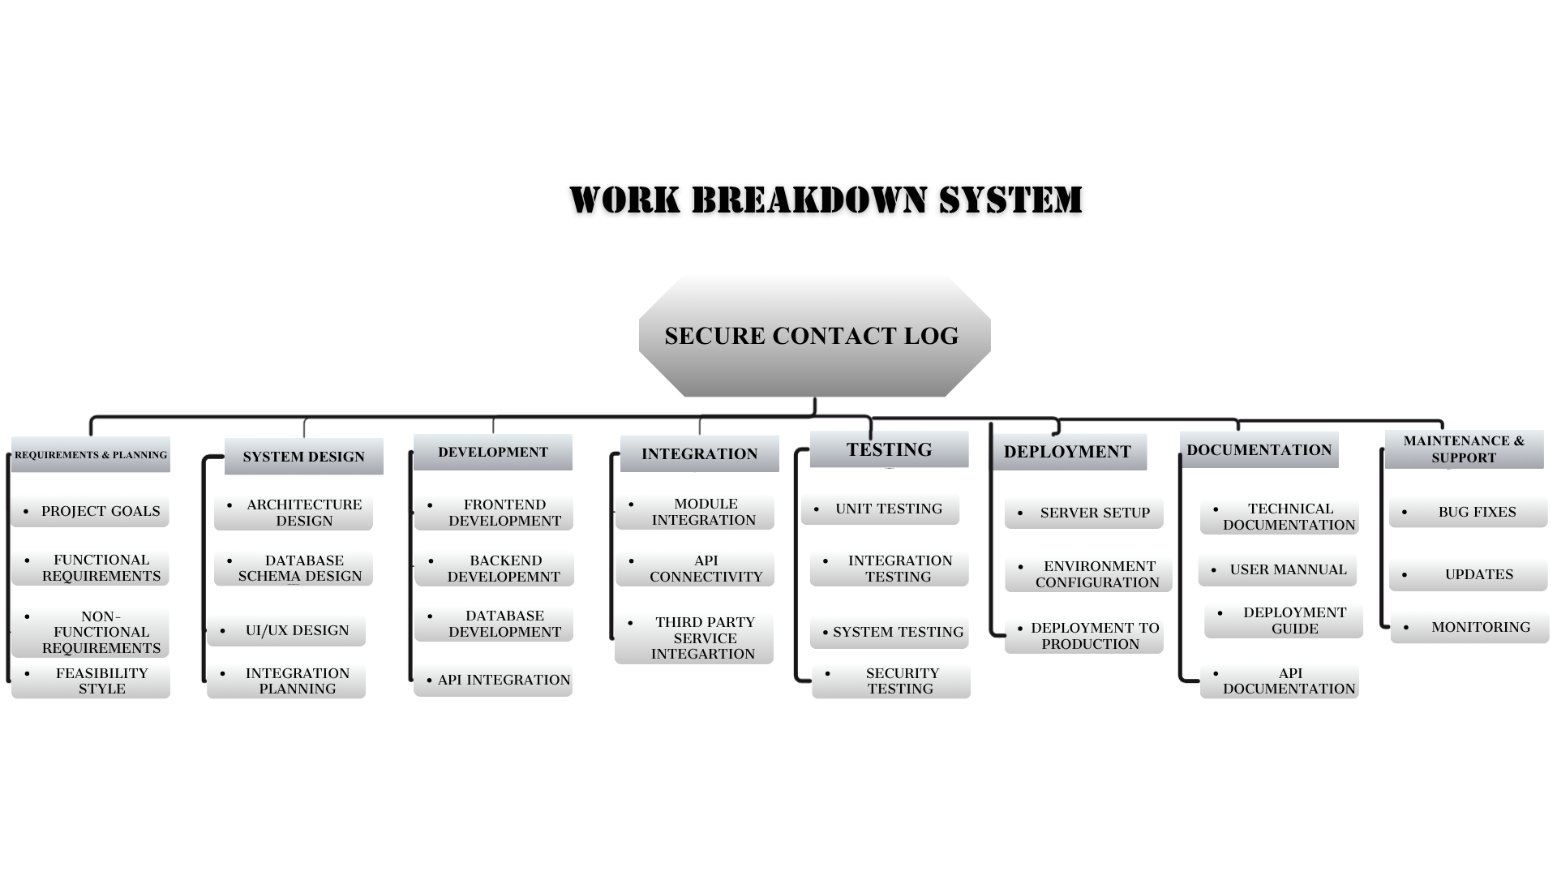

GANTT CHART :
It’s a visual timeline of a project that shows tasks, their duration, and when they start and finish. It helps track progress and plan schedules.
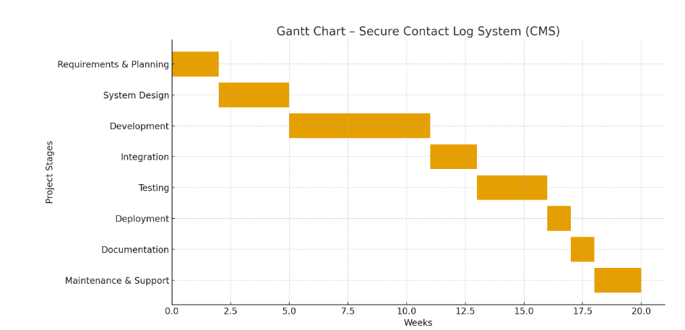
Shows project tasks, durations, and timelines for easy tracking.
- Requirements & Planning: 0.0 – 2.5 weeks
- Design & Architecture: 2.5 – 5.0 weeks
- Development / Coding: 5.0 – 10.0 weeks
- Testing & Integration: 10.0 – 15.0 weeks
- Deployment & Documentation: 15.0 – 17.5 weeks
- Maintenance & Support : 17.5_20.0 weeks
In Case of Remaining time, You can use your time for review , buffer and project closure.

